On head tag we can add

1. External file links (JS, CSS etc)
2. Scripts
3. Meta tags (meta description, meta title etc)
4. Title.

**HTML Entity:**

Reserved characters in HTML must be replaced with html Entities. We can get a complete list of entities if we search google.

Some example-

1. Normally we can use only one space between each word (exception maybe **blockquote**). To force more space, we can use entity **&nbs** which stands for non-breaking space.

**Links:**

We use anchor element for links. It must have href attribute (hypertext reference).

* We can use website URL here or absolute or relative URL.
* We can also put id here making bookmark for different section of same page.
* We can use email address here for sending email



**Images:**

We can use img tag for this. We can define src and alt text for the image here. Rest of the properties should be edited in the CSS.



**Absolute vs relative URL:**

Difference Is for absolute URL we can specify full website name or full path from root directory.



Relative URL is good for redirecting in between pages.

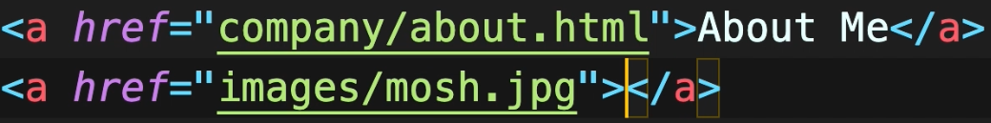

* To make something available for download, we can use the Boolean (in html they aren’t true and false, their presence means true absence means false) attribute **download** inside an element.



**Video and Audio:**



Very similar for audio as well. We can add error text in between the tags in case the browser doesn’t support the feature

**Lists:**

By default, unordered lists are shown as bullet points. In case of ordered list we get numbered list.

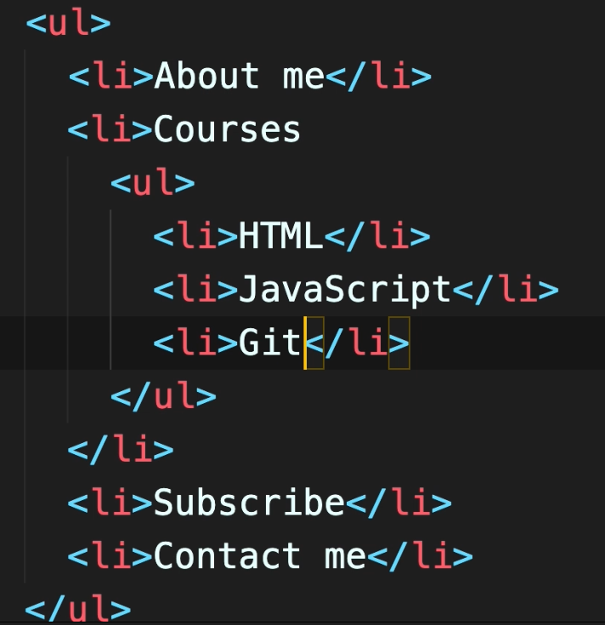 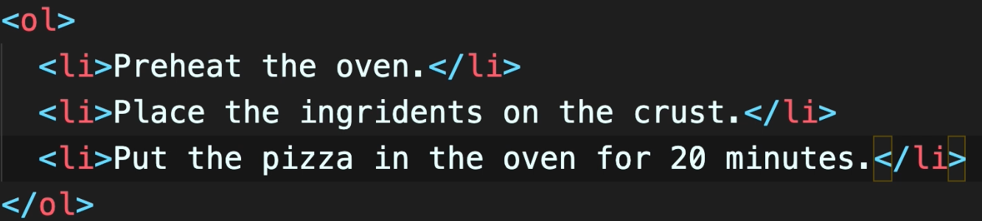

There is another type of list called description list,

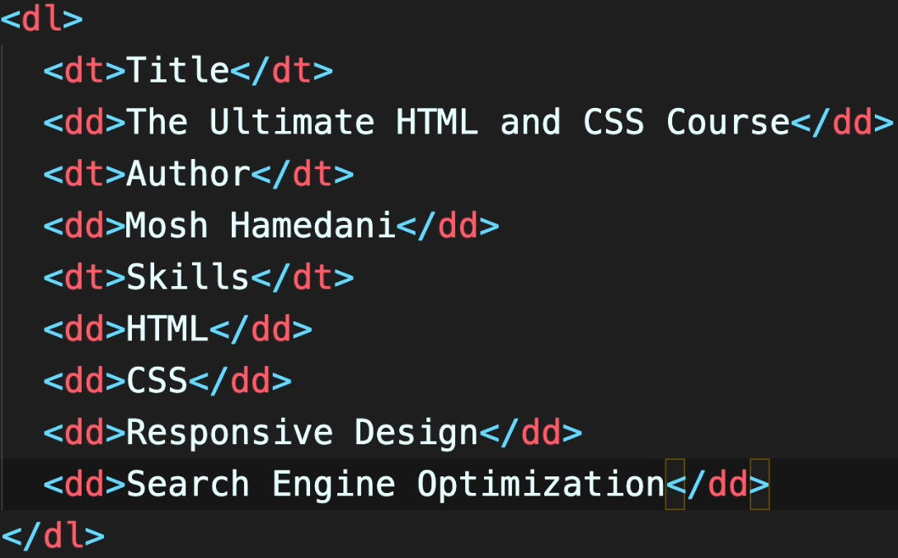 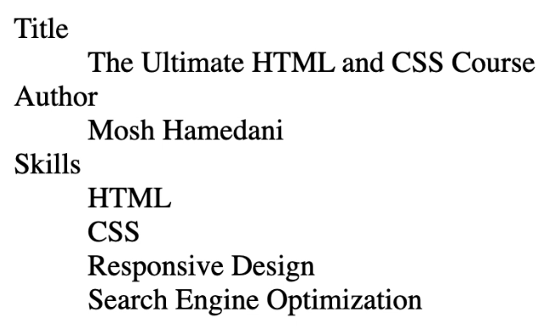

**Table:**

This is the general way of makign table.

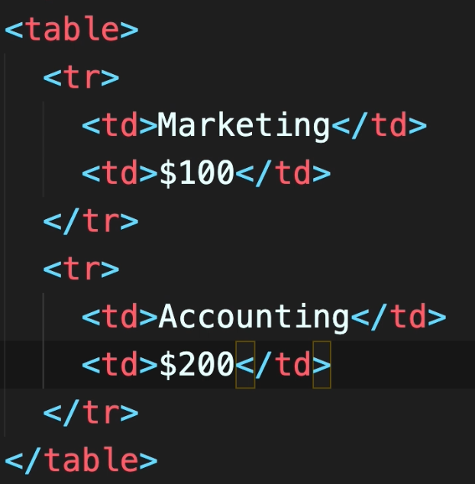

But using semantics we can make it more meaningful for search engines to access. So, a better structure inside the **table** tag would be as below by making **thead** and **tbody** sections. We can add **tfoot** section too if needed.

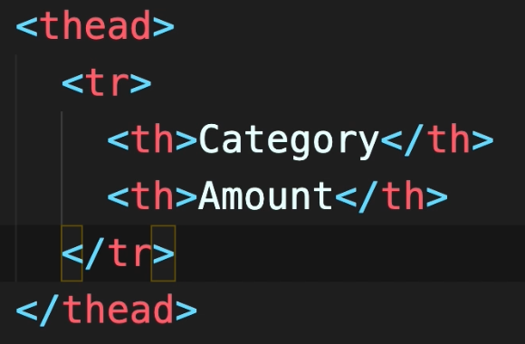 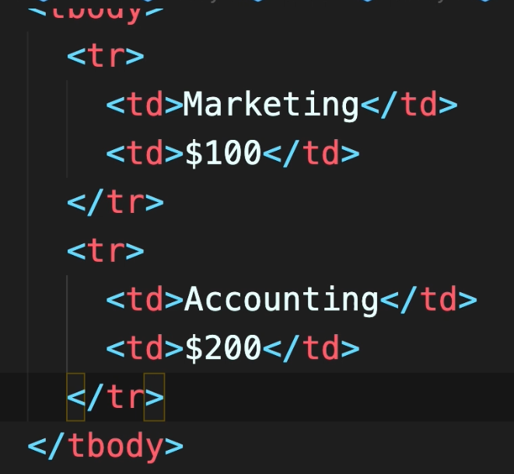

* For problem with borders of table not touching each other, we can use css property **border-collapse: collapse.**
* We can use **colspan=2** to make it span 2 columns or any number.

**Container element:** div and span are general purpose container element. div is a block level element and span is an inline element. HTML5 brings few more semantic containers like article, section, mark (same as span), time, figure, header, footer etc.